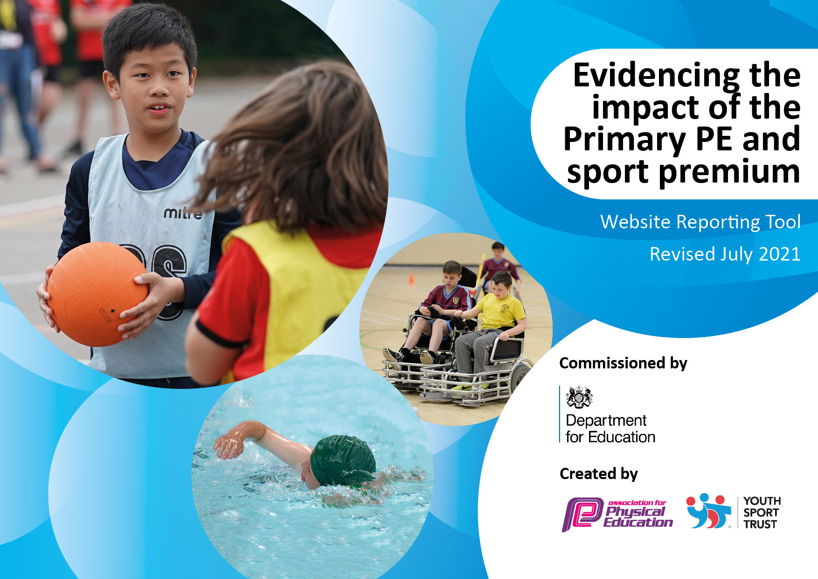
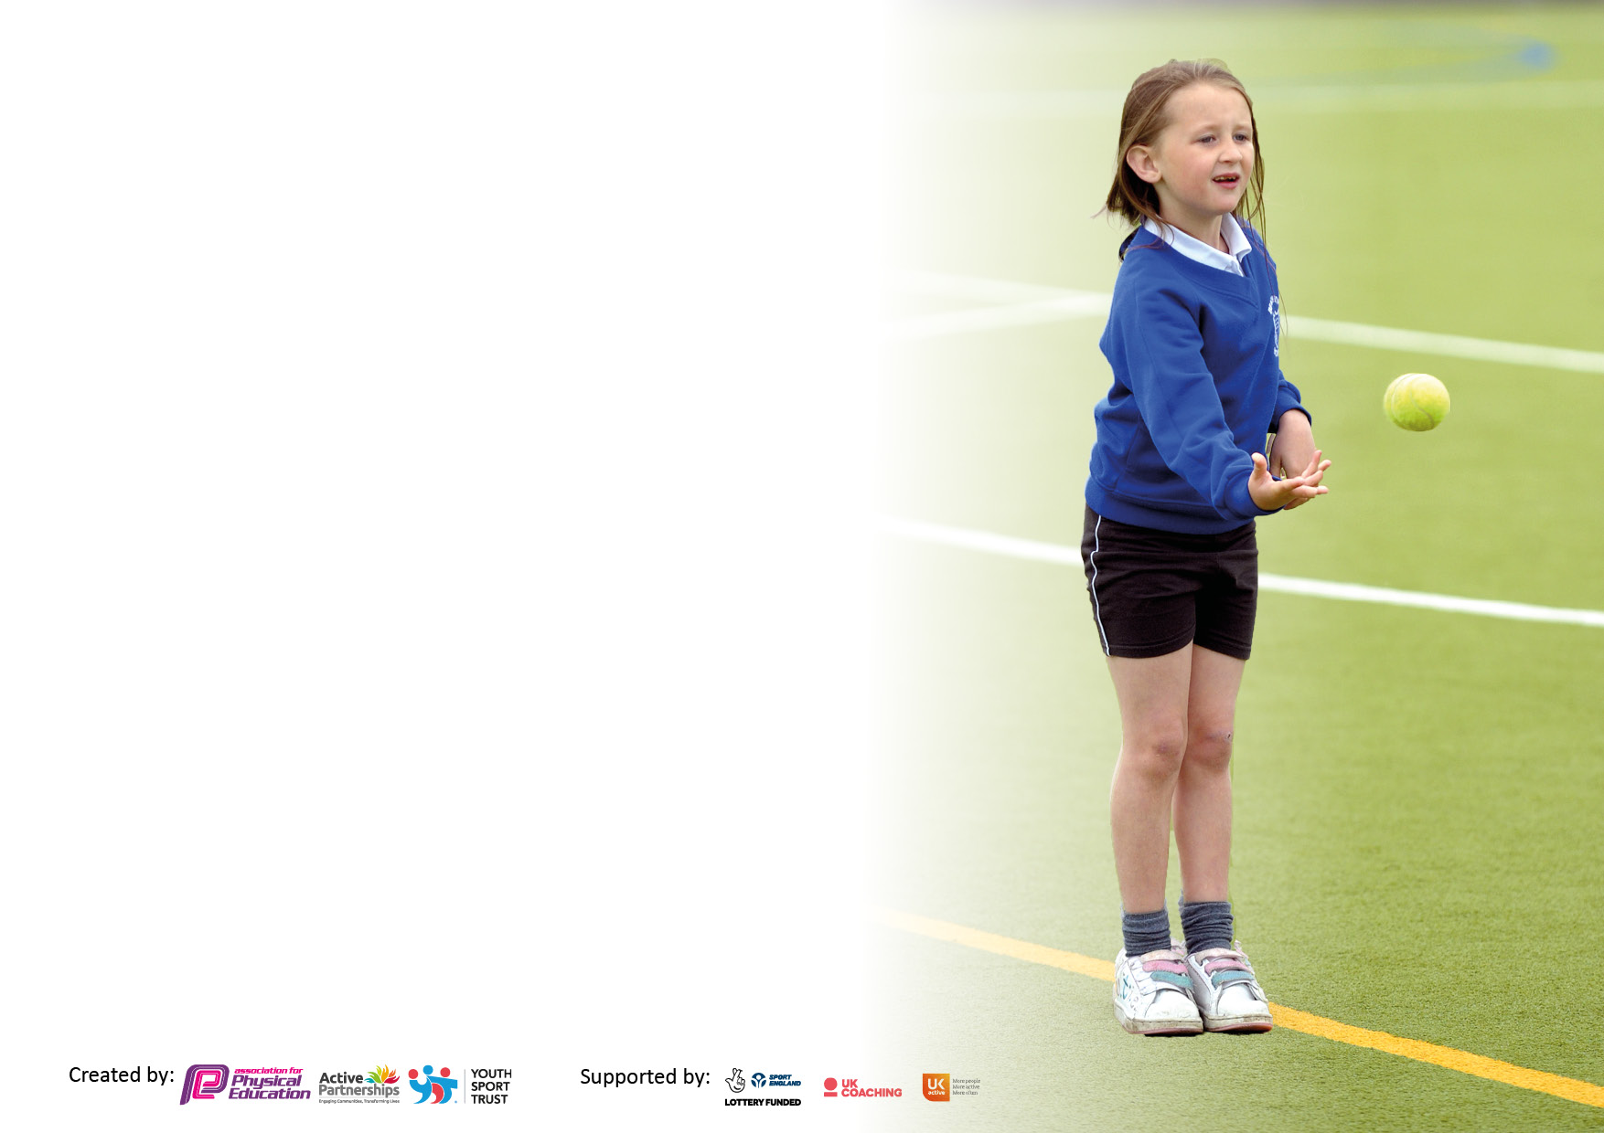

It is important that your grant is used effectively and based on school need. The Education Inspection Framework makes clear there will be a focus on ‘whether leaders and those responsible for governors all understand their respective roles and perform these in a way that enhances the effectiveness of the school’.

Under the Quality of Education Ofsted inspectors consider:
Intent - Curriculum design, coverage and appropriateness
Implementation - Curriculum delivery, Teaching (pedagogy) and Assessment
Impact - Attainment and progress

To assist schools with common transferable language this template has been developed to utilise the same three headings which should make your plans easily transferable between working documents.

Schools must use the funding to make additional and sustainable improvements to the quality of Physical Education, School Sport and Physical Activity (PESSPA) they offer. This means that you should use the Primary PE and sport premium to:

- Develop or add to the PESSPA activities that your school already offer
- Build capacity and capability within the school to ensure that improvements made now will benefit pupils joining the school in future years
- The Primary PE and sport premium should not be used to fund capital spend projects; the school’s budget should fund these.

Pleasevisitgov.ukfortherevisedDfEguidanceincludingthe5keyindicatorsacrosswhichschoolsshoulddemonstrate animprovement.Thisdocumentwillhelpyoutoreviewyourprovisionandtoreportyourspend.DfEencouragesschools to use this template as an effective way of meeting the reporting requirements of the Primary PE and sport premium.

We recommend you start by reflecting on the impact of current provision and reviewing the previous spend.

Schools are required to publish details of how they spend this funding, including any under-spend from 2019/2020, as well as on the impact it has on pupils’ PE and sport participation and attainment. All funding must be spent by 31st July 2022.

We recommend regularly updating the table and publishing it on your website throughout the year. This evidences your ongoing self-evaluation of how you are using the funding to secure maximum, sustainable impact. Final copy must be posted on your website by the end of the academic year and no later than the 31st July 2021. To see an example of how to complete the table please click HERE.


Created by: Supported by:

Details with regard to funding
Please complete the table below.

Total amount carried over from 2019/20 | £19559.38
Total amount allocated for 2020/21 | £16550
How much (if any) do you intend to carry over from this total fund into 2021/22? | £18803
Total amount allocated for 2021/22 | £16550
Total amount of funding for 2021/22. To be spent and reported on by 31st July 2022. | £
Swimming Data
Please report on your Swimming Data below.

Meeting national curriculum requirements for swimming and water safety.

N.B. Complete this section to your best ability. For example you might have practised safe self-rescue techniques on dry land which you can then transfer to the pool when school swimming restarts.
Due to exceptional circumstances priority should be given to ensuring that pupils can perform safe self rescue even if they do not fully meet the first two requirements of the NC programme of study
What percentage of your current Year 6 cohort swim competently, confidently and proficiently over a distance of at least 25 metres?  N.B. Even though your pupils may swim in another year please report on their attainment on leaving primary school at the end of the summer term 2020.  Please see note above | 100%
What percentage of your current Year 6 cohort use a range of strokes effectively [for example, front crawl, backstroke and breaststroke]?  Please see note above | 100%
What percentage of your current Year 6 cohort perform safe self-rescue in different water-based situations? | 100%
Schools can choose to use the Primary PE and sport premium to provide additional provision for swimming but this must be for activity over and above the national curriculum requirements. Have you used it in this way? | Yes/No

Action Plan and Budget Tracking
Capture your intended annual spend against the 5 key indicators. Clarify the success criteria and evidence of impact that you intend to measure to evaluate for pupils today and for the future.

Academic Year: 2021/22 | Total fund allocated: | Date Updated:
Key indicator 1: The engagement of all pupils in regular physical activity – Chief Medical Officers guidelines recommend that primary school pupils undertake at least 30 minutes of physical activity a day in school |  |  |  | Percentage of total allocation:
 |  |  |  | %
Intent | Implementation |  | Impact
Your school focus should be clear what you want the pupils to know and be able to do and about  what they need to learn and to  consolidate through practice: | Make sure your actions to achieve are linked to your intentions: | Funding allocated: | Evidence of impact: what do pupils now know and what can they now do? What has changed?: | Sustainability and suggested next steps:
To continue to promote healthy active lifestyles across the school.  To improve the provision of equipment to encourage active play at playtimes and offer a range of activities/sports. | Pupils to become more active both inside and outside of school through PE and after school activities.  To improve the provision of equipment. | £500 | 2 hours of PE to be evident on timetables.  Use of Daily Mile track  Pupils have the opportunity to be active at playtimes and develop skills learnt. | PE co-ordinator to monitor timetables  Ensure time is available for all classes to complete Daily Mile
Key indicator 2: The profile of PESSPA being raised across the school as a tool for whole school improvement |  |  |  | Percentage of total allocation:
 |  |  |  | %
Intent | Implementation |  | Impact
Your school focus should be clear what you want the pupils to know and be able to do and about  what they need to learn and to  consolidate through practice: | Make sure your actions to achieve are linked to your intentions: | Funding allocated: | Evidence of impact: what do pupils now know and what can they now do? What has changed?: | Sustainability and suggested next steps:
Profile of PE and Sports raised across the school as a tool for school improvement. | School Partnership- The Corbet participation in cluster tournaments at The Corbet school. Achievements and placements celebrated within school. | £600 | Development of Sportsmanship between schools and classes- working together as a team. Winning with grace, fair play. | Schools Partnership to continue next year.  Continue to develop role of PE co-ordinator.

Key indicator 3: Increased confidence, knowledge and skills of all staff in teaching PE and sport |  |  |  | Percentage of total allocation:
 |  |  |  | %
Intent | Implementation |  | Impact
Your school focus should be clear | Make sure your actions to | Funding | Evidence of impact: what do | Sustainability and suggested
what you want the pupils to know | achieve are linked to your | allocated: | pupils now know and what | next steps:
and be able to do and about | intentions: |  | can they now do? What has
what they need to learn and to |  |  | changed?:
consolidate through practice:
Ensure high quality, specialist coaching which will enhance the learning experiences for the children and upskill the teachers.  Knowledge and confidence of PE Co-Ordinator will be increased to ensure good quality provision of PE is delivered throughout the school. | Sports Coaching (STiTC, Connor Beesty Coaching)  PE Co-ordinator to engage with coaches and monitor in areas teachers feel they need support.  Teachers to be present within lessons delivered by coaches.  Swimming has been re-established for Yrs 2-4 and those children who cannot swim 25m  PE Co-Ordinator to liaise with coaches to develop short, medium and long term plans. | £6500  £1050 | Specialist PE coaches help to promote their sport significantly, provide enthusiasm and encouragement to both teachers and staff. They help children to reach their age-related expectations.  Upskilling the teachers through the coaches enable teachers to become more confident in delivering PE sessions.  Development of planning to ensure a wide variety of sports and skills are being taught. | Re-book for next year. Pe Co-Ordinator to oversee planning and delivery.  Re-book for next year.  Continued development of provision for all children.
Key indicator 4: Broader experience of a range of sports and activities offered to all pupils |  |  |  | Percentage of total allocation:
Intent | Implementation |  | Impact
Your school focus should be clear | Make sure your actions to | Funding | Evidence of impact: what do | Sustainability and suggested
what you want the pupils to know | achieve are linked to your | allocated: | pupils now know and what | next steps:
and be able to do and about | intentions: |  | can they now do? What has
what they need to learn and to |  |  | changed?:
consolidate through practice:
Purchase of ‘Hideaway Hut’ for Forest Fun and Outdoor Learning and implementation of Forest Leader to deliver Forest Fun sessions.  Pupils to experience and have access to a variety of sports. To gain confidence and to try new activities. | Children in all year groups to have the opportunity to access outdoor learning and Forest Fun.  - Tennis experience day  - Bikeability  - Sports Day  - PE lessons to include Yoga | £13,000  Free  Free  Free | Children are able to explore and be outside for more time increasing their physical activity within school. Children are encouraged to spend time outside in nature. | Forest Fun and Outdoor learning to be timetabled for all classes (PE Co-Ordinator to oversee)  Continue to offer these throughout the year.

Key indicator 5: Increased participation in competitive sport |  |  |  | Percentage of total allocation:
 |  |  |  | %
Intent | Implementation |  | Impact
Your school focus should be clear | Make sure your actions to | Funding | Evidence of impact: what do | Sustainability and suggested
what you want the pupils to know | achieve are linked to your | allocated: | pupils now know and what | next steps:
and be able to do and about | intentions: |  | can they now do? What has
what they need to learn and to |  |  | changed?:
consolidate through practice:
Continued opportunity to take part in both competitive and non-competitive sports activites alongside their peers.  Enable social skills to be developed and gain confidence within different areas and build relationships with other schools.  Sports Day to be held within school | Inter schools sports partnership with the Corbet feeder schools  Bowmere Heath Area Sports Competition  Allow all (N-Y6) children to participate within sports activities | £500 | Working and being part of a team.  All of UKS2 (18) have been to at least one competitive event over the year.  Applying and developing appropriate skills for different sports.  Sportsmanship and working within teams. Applying skills learnt within PE sessions | Continue to take part in Corbet Sports Offer

Signed off by
Head Teacher:
Date:
Subject Leader:
Date:
Governor:
Date:

